You have a class named Customer and a class named Order.  
The customer class has a property named Orders that contains a list of Order objects.  
The Order class has a property named OrderDate that contains the date of the Order.  
You need to create a LINQ query that returns all of the customers who had at least one order during the year 2005. You write the following code.

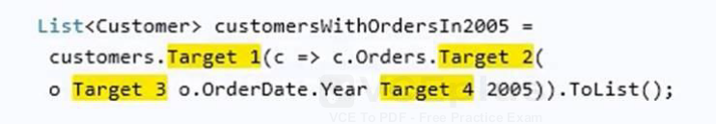

**List customersWithOrdersIn2005 = customers.Where(c => c.Orders.Any(o => o.OrderDate.Year == 2005)).ToList();**

You are building an application in Microsoft Visual Studio 2013.  
You have the following code.

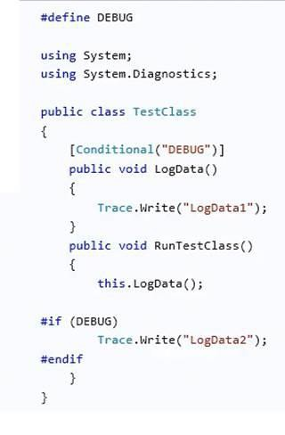**Yes, yes, yes**

You have a C# application.  
The application requires 500 MB of available memory.  
You need to identify whether there is enough available memory when the application starts.  
Which class should you use? **PerformanceCounter**

You have the following code: 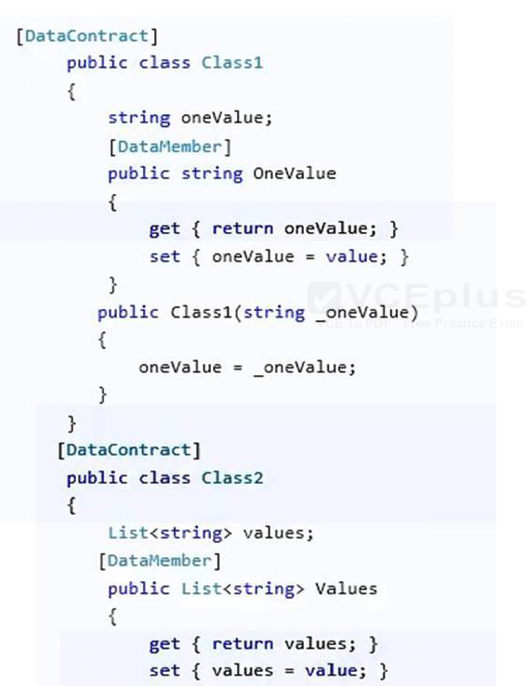

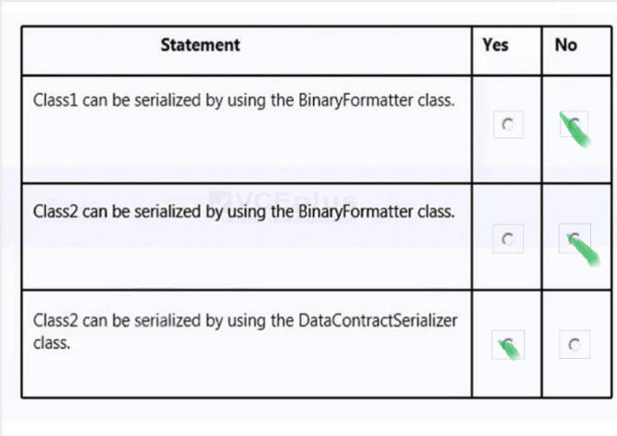

You are developing a function that takes a parameter named aParam as a string input.  
You need to convert aParam to a Double. If the conversion cannot be completed, the function should return 0

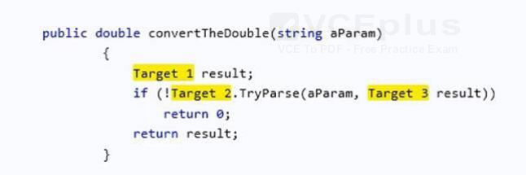

**public double convertTheDouble(string aParam)  
{  
double result;  
if (!double.TryParse(aParam, out result))  
return 0;  
return result;  
}**

You are creating a console application named Appl.  
App1 retrieves data from the Internet by using JavaScript Object Notation (JSON).  
You are developing the following code segment (line numbers are included for reference only):

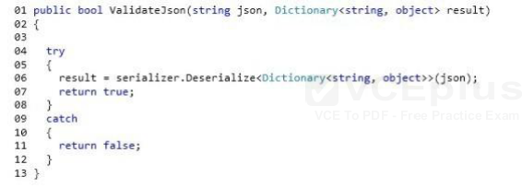

You need to ensure that the code validates the JSON string.  
Which code should you insert at line 03?

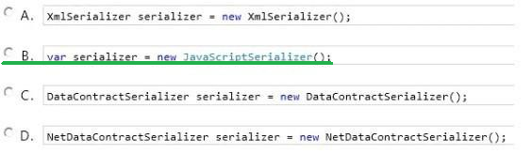

You are testing an application. The application includes methods named CalculateInterest and LogLine. The CalculateInterest() method calculates loan interest. The LogLine() method sends diagnostic messages to a console window.  
The following code implements the methods. (Line numbers are included for reference only.)

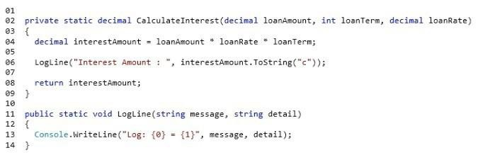  
You have the following requirements:  
The CalculateInterest() method must run for all build configurations.  
The LogLine() method must run only for debug builds.  
You need to ensure that the methods run correctly.  
What are two possible ways to achieve this goal?

**Insert the following code segment at line 10:**  
[Conditional(“DEBUG”)]

**Insert the following code segment at line 05:**  
#if DEBUG  
Insert the following code segment at line 07:  
#endif

You have a class named Customer and a variable named customers.  
You need to test whether the customers’ variable is a generic list of Customer objects.  
Which line of code should you use?

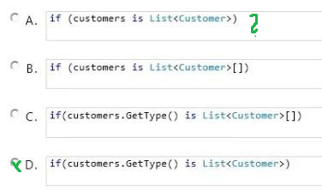

You are creating an application that reads from a database.  
You need to use different databases during the development phase and the testing phase by using conditional compilation techniques.  
What should you do? **Specify the /define compiler option.**

You have the following code.  
string MessageString = ?his is the original message!?  
You need to store the SHA1 hash value of MessageString in a variable named HashValue.  
Which code should you use? Develop the solution by selecting and arranging the required code blocks in the correct order. You may not need all of the code blocks.

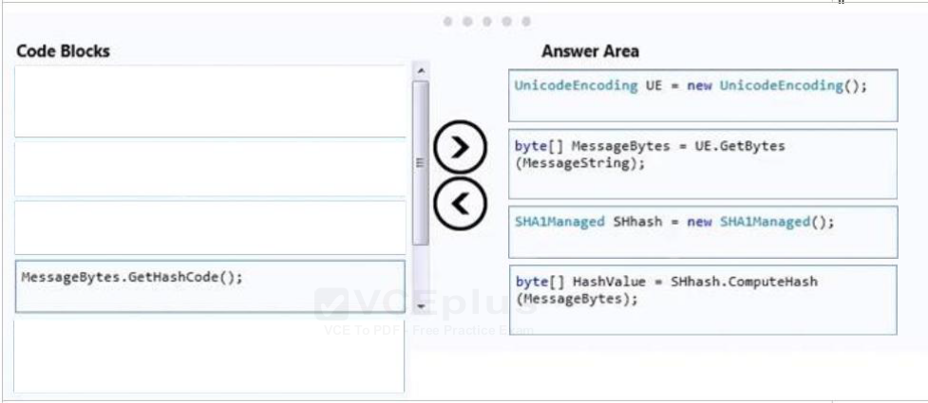

You write the following method (line numbers are included for reference only):

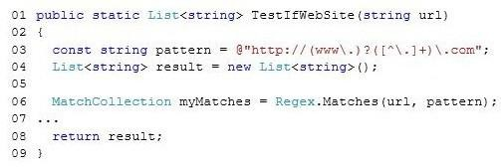  
You need to ensure that the method extracts a list of URLs that match the following pattern:  
@http://(www.)?([^.]+).com;  
Which code should you insert at line 07?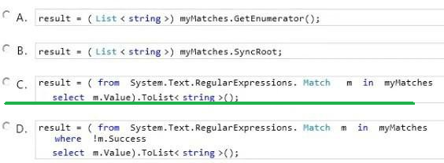

You are developing an application that implements a set of custom exception types. You declare the custom exception types by using the following code segments:

https://vceguide.com/wp-content/uploads/2017/02/70-483-programming-in-c_Image_627.jpg  
The application includes a function named DoWork that throws .NET Framework exceptions and custom exceptions. The application contains only the following logging methods:

https://vceguide.com/wp-content/uploads/2017/02/70-483-programming-in-c_Image_628.jpg  
The application must meet the following requirements:  
When ContosoValidationException exceptions are caught, log the information by using the static void Log (ContosoValidationException ex) method.  
When ContosoDbException or other ContosoException exceptions are caught, log the information by using the static void Log(ContosoException ex) method.  
You need to meet the requirements.  
You have the following code:

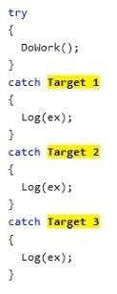  
Which code segments should you include in Target 1, Target 2 and Target 3 to complete the code? (To answer, drag the appropriate code segments to the correct targets in the answer area. Each code segment may be used once, more than once, or not at all. You may need to drag the split bar between panes or scroll to view content.)  
Select and Place: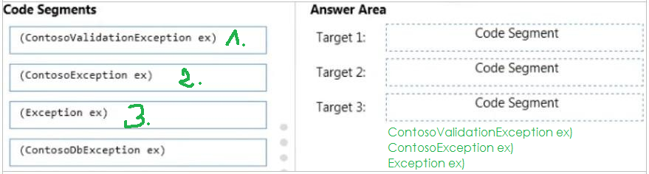

You need to write a console application that meets the following requirements:  
If the application is compiled in Debug mode, the console output must display Entering debug mode.  
If the application is compiled in Release mode, the console output must display Entering release mode.  
Which code should you use?

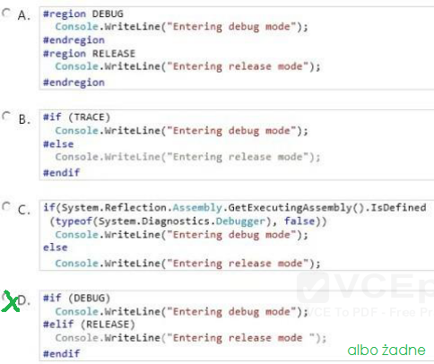

You write the following code.

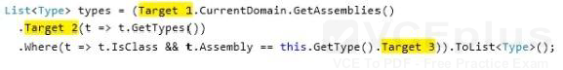  
You need to get the list of all the types defined in the assembly that is being executed currently.

**List types2 = AppDomain.CurrentDomain.GetAssemblies().  
SelectMany(t => t.GetTypes())  
.Where(t => t.IsClass && t.Assembly == GetType().Assembly).ToList<>();**

You are developing an application that includes methods named ConvertAmount and TransferFunds.  
You need to ensure that the precision and range of the value in the amount variable is not lost when the TransferFunds() method is called.  
Which code segment should you use? **Decimal**

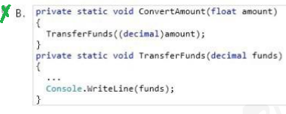

A developer designs an interface that contains the following code:

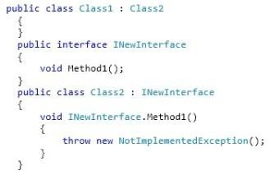

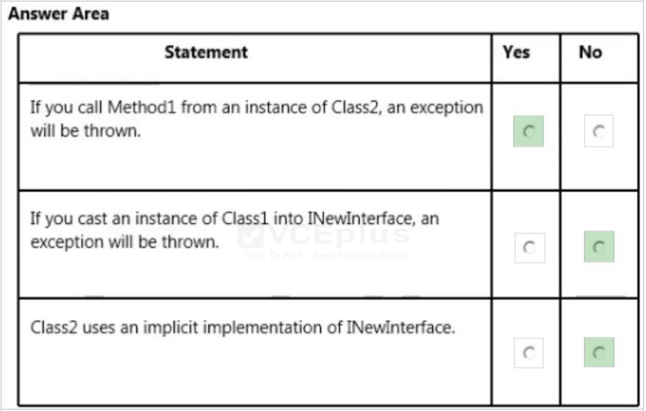

You have the following code (line numbers are included for reference only):

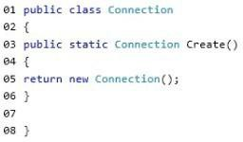  
You need to ensure that new instances of Connection can be created only by other classes by calling the Create method. The solution must allow classes to inherit from Connection.  
What should you do?

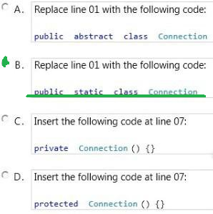

You have the following class. (Line numbers are included for reference only.)

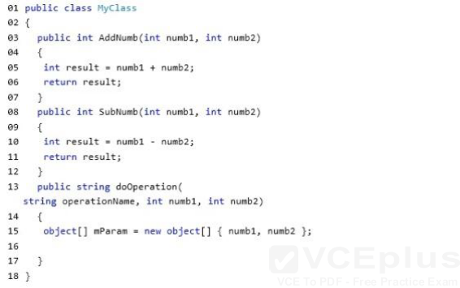  
You need to complete the doOperation method to meet the following requirements:  
If AddNumb is passed as the operationName parameter, the AddNumb function is called.  
If SubNumb is passed as the operationName parameter, the SubNumb function is called.  
Which code should you insert at line 16? Develop the solution by selecting and arranging the required code blocks in the correct order. You may not need all of the code blocks.  
Select and Place:

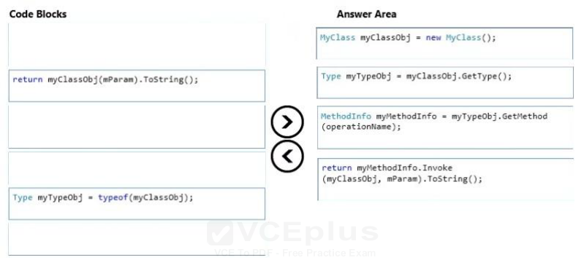

You are creating a class named Data that includes a dictionary object named _data.  
You need to allow the garbage collection process to collect the references of the _data object.  
You have the following code:

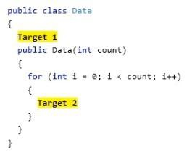  
Which code segments should you include in Target 1 and Target 2 to complete the code?

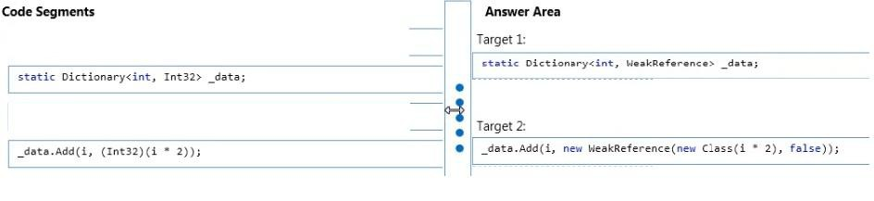

You are developing a class named Temperature.  
You need to ensure that collections of Temperature objects are sortable. You have the following code:

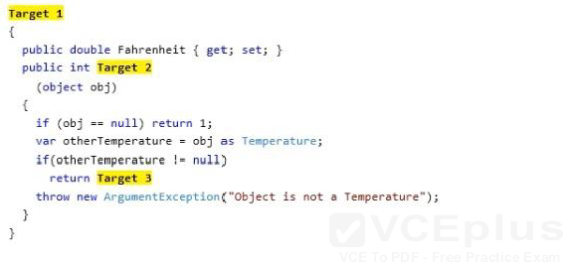  
Which code segments should you include in Target 1, Target 2 and Target 3 to complete the code?

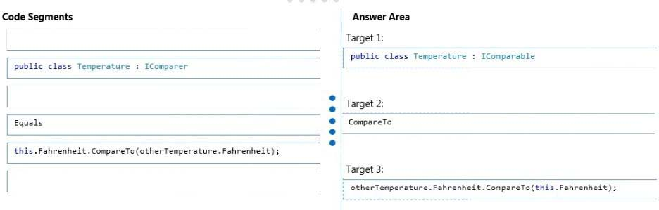

You are developing an application that contains a class named TheaterCustomer and a method named ProcessTheaterCustomer. The ProcessTheaterCustomer() method accepts a TheaterCustomer object as the input parameter.  
You have the following requirements:  
Store the TheaterCustomer objects in a collection.  
Ensure that the ProcessTheaterCustomer() method processes the TheaterCustomer objects in the reverse order in which they are placed into the collection.  
You need to meet the requirements.  
What should you do? **Create a System.Collections.Stack collection. Use the Push() method to add TheaterCustomer objects to the collection. Use the Pop() method to pass the objects to the ProcessTheaterCustomer() method.**

ou have the following code. (Line numbers are included for reference only).

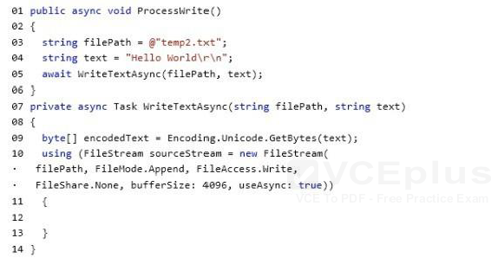  
You need to complete the WriteTextAsync method. The solution must ensure that the code is not blocked while the file is being written. Which code should you insert at line 12?

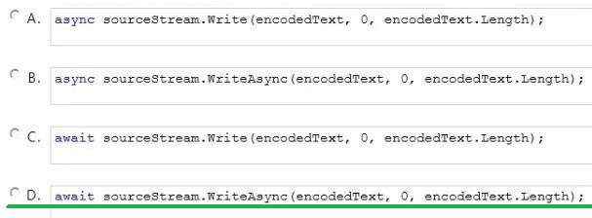

You need to write a method that retrieves data from a Microsoft Access 2013 database. The method must meet the following requirements:  
Be read-only.  
Be able to use the data before the entire data set is retrieved.  
Minimize the amount of system overhead and the amount of memory usage.  
Which type of object should you use in the method? **DbDataReader *class***

You have the following code:

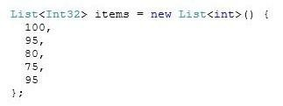  
You need to retrieve all of the numbers from the items variable that are greater than 80.  
Which code should you use?

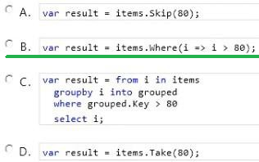

An application serializes and deserializes XML from streams. The XML streams are in the following format:

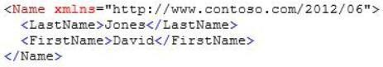  
The application reads the XML streams by using a DataContractSerializer object that is declared by the following code segment:

https://vceguide.com/wp-content/uploads/2017/02/70-483-programming-in-c_Image_588.jpg  
You need to ensure that the application preserves the element ordering as provided in the XML stream.  
You have the following code:

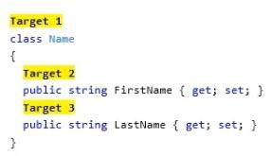  
Which attributes should you include in Target 1, Target 2 and Target 3 to complete the code? (To answer, drag the appropriate attributes to the correct targets in the answer area. Each attribute may be used once, more than once, or not at all. You may need to drag the split bar between panes or scroll to view content.)  
Select and Place:

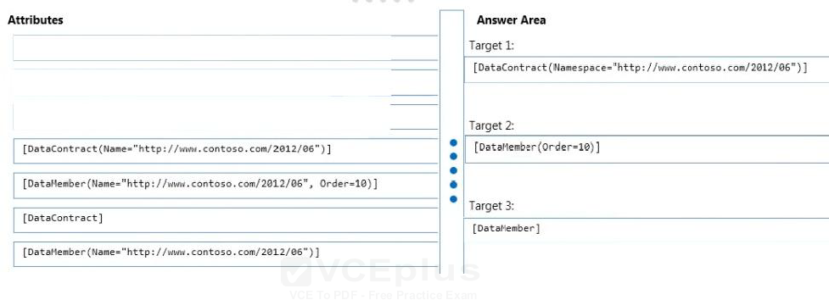

When you execute the code, you get an exception.

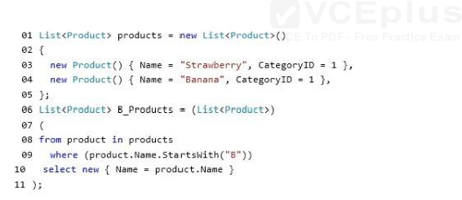  
You need to ensure that B_Products contain all of the products that start with the letter “B”.  
What should you do?

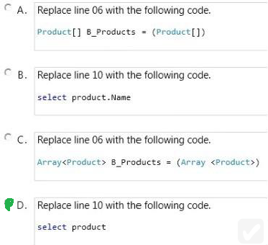

You are developing a C# application. The application includes a class named Rate. The following code segment implements the Rate class:

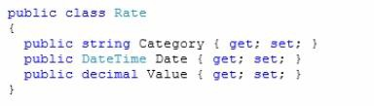  
You define a collection of rates named rateCollection by using the following code segment: CollectionrateCollection = new Collection() ;  
The application receives an XML file that contains rate information in the following format:

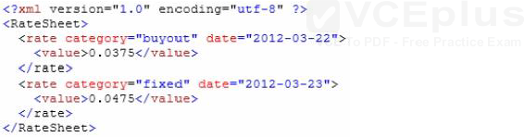  
You need to parse the XML file and populate the rateCollection collection with Rate objects.  
You have the following code:

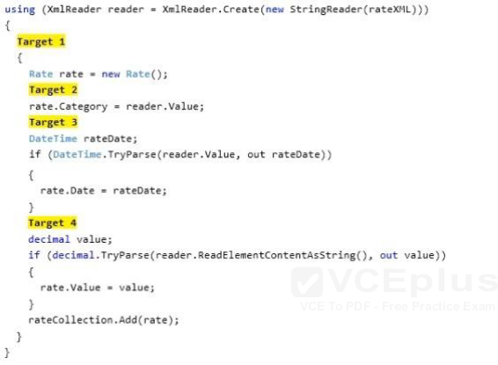  
Which code segments should you include in Target 1, Target 2, Target 3 and Target 4 to complete the code?

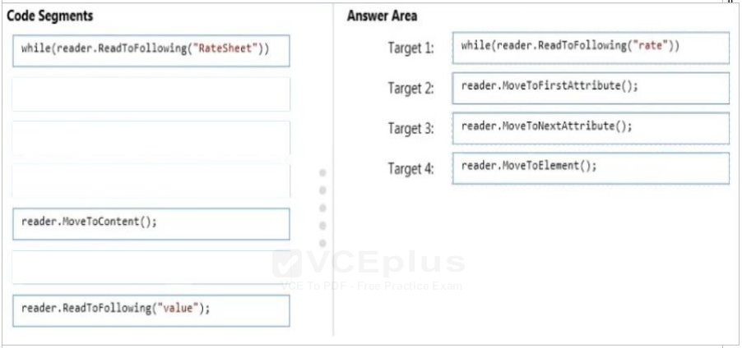

You are modifying an existing application.  
The application includes a Loan class and a Customer class. The following code segment defines the classes.

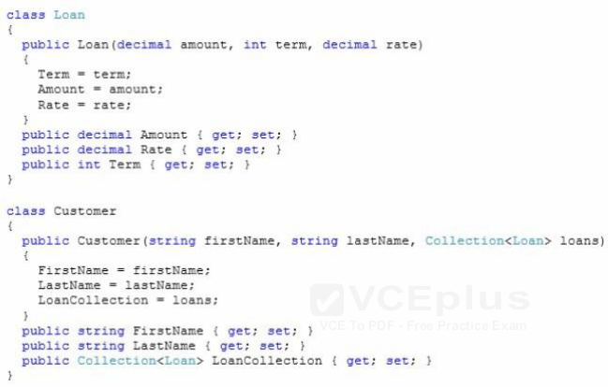  
You populate a collection named customer-Collection with Customer and Loan objects by using the following code segment:

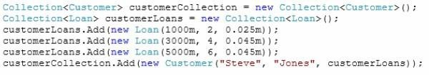  
You create a largeCustomerLoans collection to store the Loan objects by using the following code segment: Collection largeCustomerLoans = new Collection();  
All loans with an Amount value greater than or equal to 4000 must be tracked.  
You need to populate the largeCustomerLoans collection with Loan objects.  
Which code segment should you use?

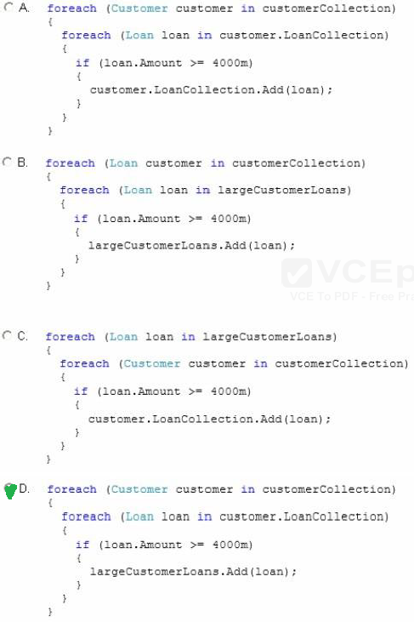

You have the following code.

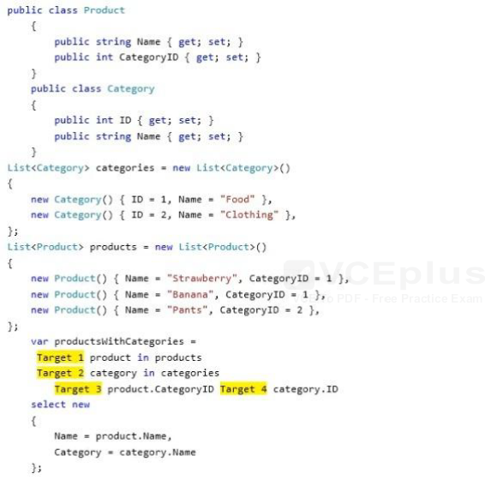  
You need to return all of the products and their associated categories.  
How should you complete the code? To answer, drag the appropriate code elements to the correct targets in the answer area. Each code element may be used once, more than once, or not at all. You may need to drag the split bar between panes or scroll to view content.

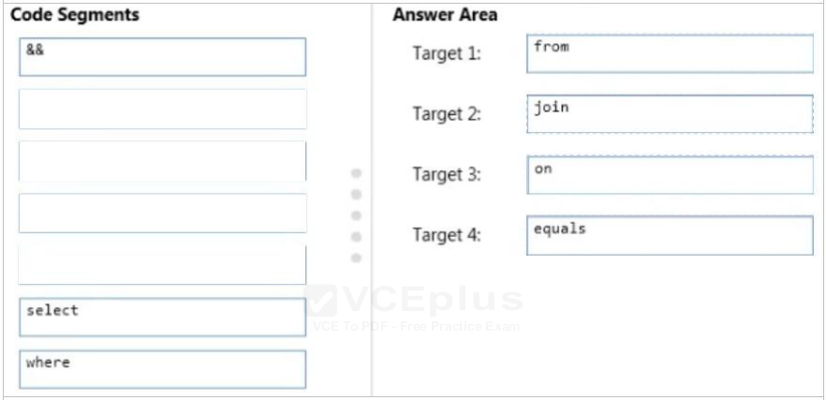

You are developing an application that will manage customer records. The application includes a method named FindCustomer.  
Users must be able to locate customer records by using the customer identifier or customer name. You need to implement the FindCustomer() method to meet the requirement.  
Which two sets of method signatures can you use to achieve this goal? (Each correct answer presents a complete solution. Choose two.)

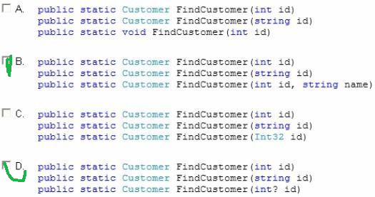

You need to write a method that combines an unknown number of strings. The solution must minimize the amount of memory used by the method when the method executes.  
What should you include in the code? **The StringBuilder.Append method**

You are implementing a method named ProcessFile that retrieves data files from web servers and FTP servers. The ProcessFile () method has the following method signature:  
Public void ProcessFile(Guid dataFileld, string dataFileUri)  
Each time the ProcessFile() method is called, it must retrieve a unique data file and then save the data file to disk. You need to complete the implementation of the ProcessFile() method. Which code segment should you use?

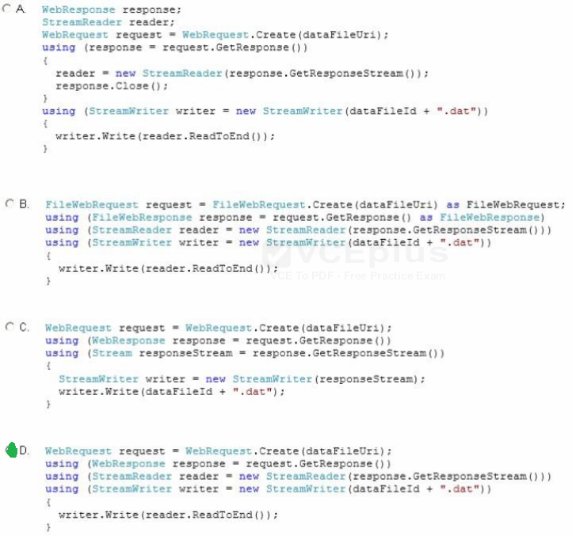

You are creating a class library that will be used in a web application.  
You need to ensure that the class library assembly is strongly named.  
What should you do? **Use assembly attributes.**

You are developing a C# application. The application includes a class named Rate. The following code segment implements the Rate class:

  
You define a collection of rates named rateCollection by using the following code segment: CollectionrateCollection = new Collection() ;  
The application receives an XML file that contains rate information in the following format:

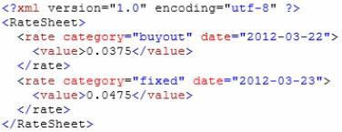  
You need to parse the XML file and populate the rateCollection collection with Rate objects.  
How should you complete the relevant code? (To answer, drag the appropriate code segments to the correct locations in the answer area. Each code segment may be used once, more than once, or not at all. You may need to drag the split bar between panes or scroll to view content.)  
Select and Place:

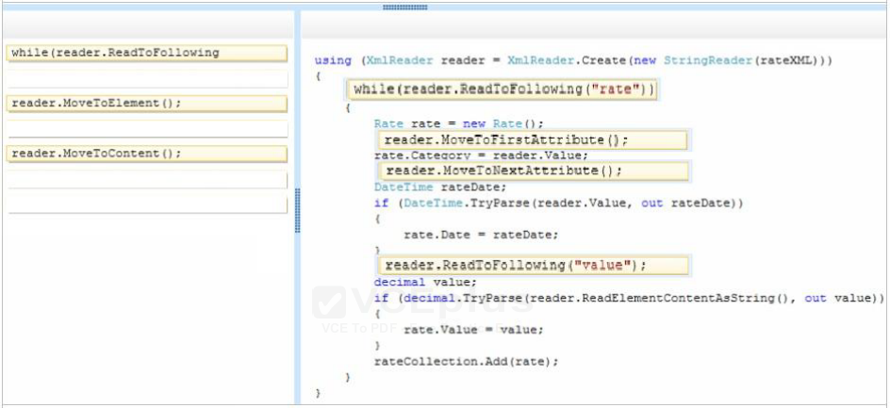

You are developing an application that will write string values to a file. The application includes the following code segment. (Line numbers are included for reference only.)  
01 protected void ProcessFile(string fileName, string value)

02 {  
3  
04 }  
You need to ensure that the ProcessFile() method will write string values to a file.  
Which four code segments should you insert in sequence at line 03?

**StreamWriter streamWriter = null;  
streamWriter = new StreamWriter(path);  
streamWriter.Write (“value”);  
streamWriter.Close();**

You need to write a console application that meets the following requirements:  
If the application is compiled in Debug mode, the console output must display Entering debug mode.  
If the application is compiled in Release mode, the console output must display Entering release mode.  
Which code should you use?

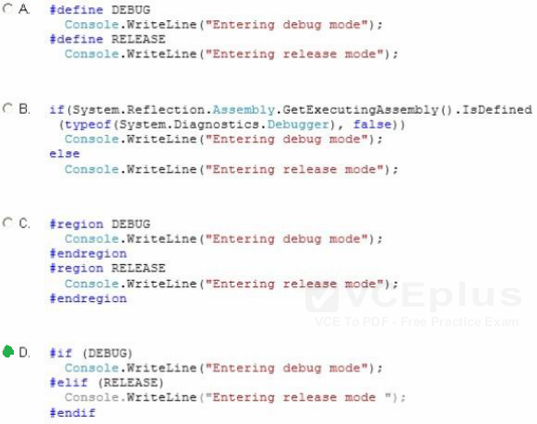

You are developing an application by using C#. The application will write events to an event log. You plan to deploy the application to a server.  
You create an event source named AppSource and a custom log named AppLog on the server. You need to write events to the custom log.  
Which code segment should you use?

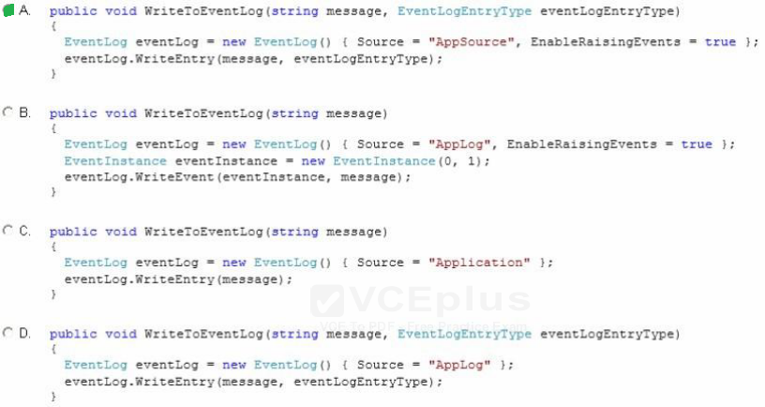

You are developing a C# application. The application includes the following code segment, (Line numbers are included for reference only.)

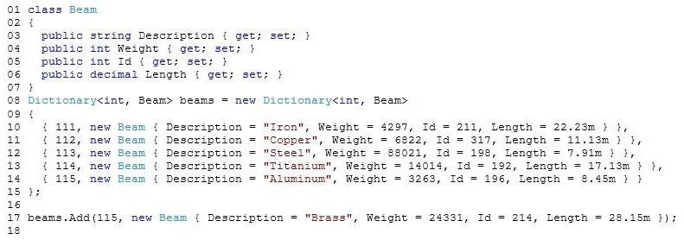  
The application fails at line 17 with the following error message: “An item with the same key has already been added.”  
You need to resolve the error.  
Which code segment should you insert at line 16?

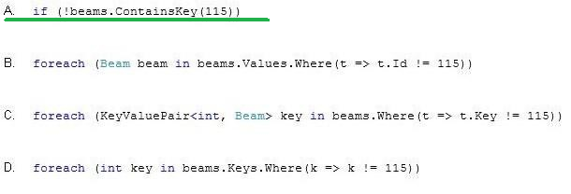

You are developing an application by using C#. The application includes a method named SendMessage. The SendMessage() method requires a string input.  
You need to replace “Hello” with “Goodbye” in the parameter that is passed to the SendMessage() method.  
Which two code segments can you use to achieve this goal? 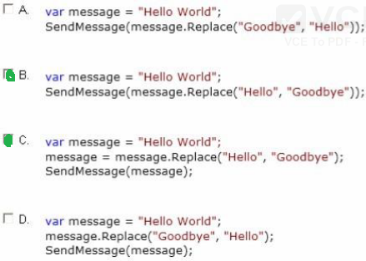

You are developing an application that includes the following code segment:

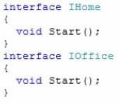  
You need to implement both Start() methods in a derived class named UseStart that uses the Start() method of each interface. Which two code segments should you use?

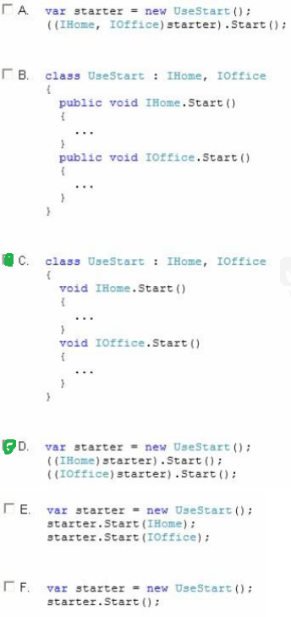

You are developing an application that will use multiple asynchronous tasks to optimize performance.  
You create three tasks by using the following code segment. (Line numbers are included for reference only.)

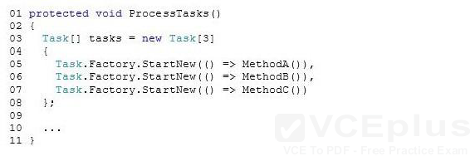  
You need to ensure that the ProcessTasks() method waits until all three tasks complete before continuing.  
Which code segment should you insert at line 09? **Task.WaitAll(tasks);**

You are evaluating a method that calculates loan interest. The application includes the following code segment. (Line numbers are included for reference only.)

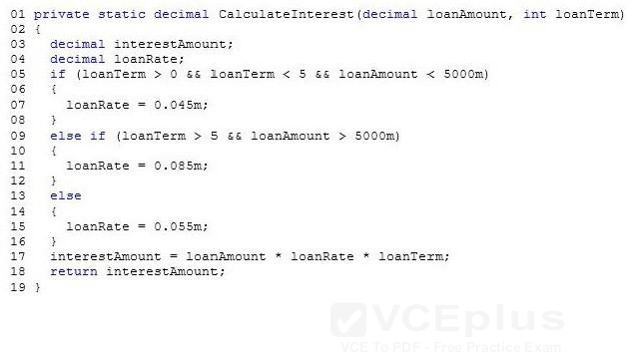  
When the loanTerm value is 5 and the loanAmount value is 4500, the loanRate must be set to 6.5 percent.  
You need to adjust the loanRate value to meet the requirements.  
What should you do? **Replace line 15 with the following code segment: loanRate = 0.065m;**

You are developing an application that includes a class named Customer and a generic list of customers. The following code segment declares the list of customers:  
List customersList = new List () ;  
You populate the customersList object with several hundred Customer objects.  
The application must display the data for five Customer objects at a time.  
You need to create a method that will return the correct number of Customer objects.  
Which code segment should you use?

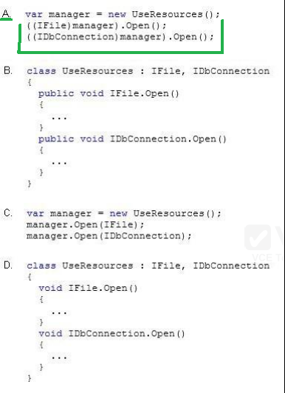

**public static IEnumerable Page(this IEnumerable source, int page, int pageSize)  
{  
return source.Skip((page – 1) * pageSize).Take(pageSize);  
}**

You are debugging a 64-bit C# application.  
Users report System.OutOfMemoryException exceptions. The system is attempting to use arrays larger than 2 GB in size. You need to ensure that the application can use arrays larger than 2 GB.  
What should you do? **Set the value of the gcAllowVeryLargeObjects property to true in the application configuration file.**

You develop an application by using C#. The application counts the number of times a specific word appears within a set of text files. The application includes the following code. (Line numbers are included for reference only.)

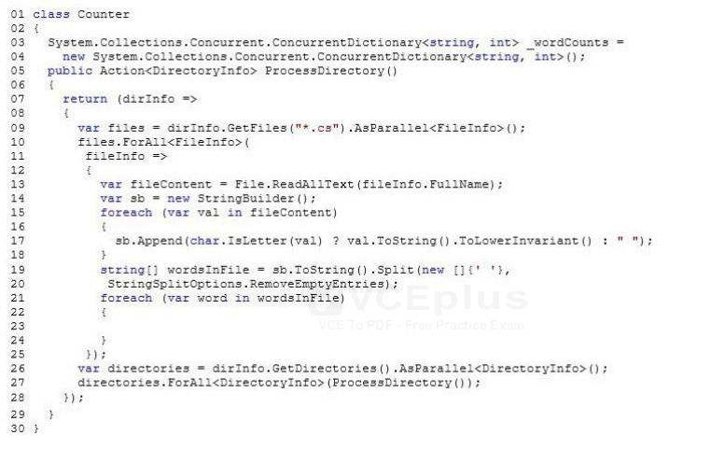  
You have the following requirements:  
Populate the _wordCounts object with a list of words and the number of occurrences of each word.  
Ensure that updates to the ConcurrentDictionary object can happen in parallel.  
You need to complete the relevant code.  
Which code segment should you insert at line 23?

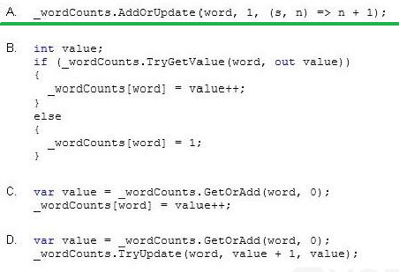

You are developing an application that will be deployed to multiple computers. You set the assembly name.  
You need to create a unique identity for the application assembly.  
Which two assembly identity attributes should you include in the source code?  **AssemblyCultureAttribute**  
 **AssemblyVersionAttribute**

You are developing an application that contains a class named TheaterCustomer and a method named ProcessTheaterCustomer. The ProcessTheaterCustomer() method accepts a TheaterCustomer object as the input parameter.  
You have the following requirements:  
Store the TheaterCustomer objects in a collection.  
Ensure that the ProcessTheaterCustomer() method processes the TheaterCustomer objects in the order in which they are placed into the collection.  
You need to meet the requirements.  
What should you do? **Create a System.Collections.Queue collection. Use the Enqueue() method to add TheaterCustomer objects to the collection. Use the Dequeue() method to pass the objects to the ProcessTheaterCustomer() method.**

You are creating an application that processes a list of numbers.  
The application must define a method that queries the list and displays a subset of the numbers to the user. The method must not update the list. You need to create an extendable query by using LINQ.  
What should you do?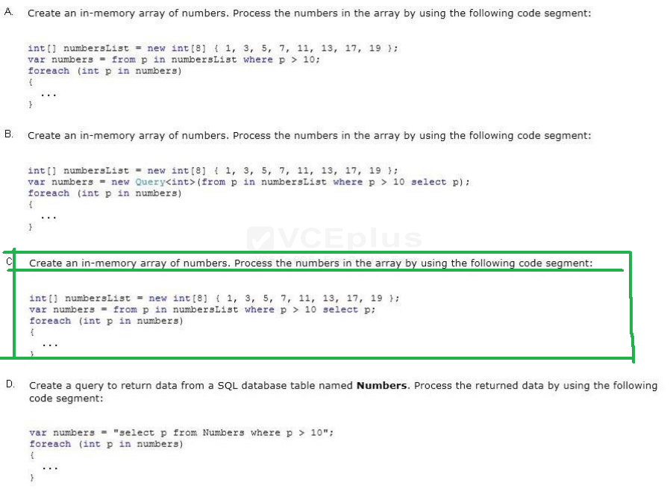

You are developing an application that includes methods named EvaluateLoan, ProcessLoan, and FundLoan. The application defines build configurations named TRIAL, BASIC, and ADVANCED.  
You have the following requirements:  
The TRIAL build configuration must run only the EvaluateLoan() method.  
The BASIC build configuration must run all three methods.  
The ADVANCED build configuration must run only the EvaluateLoan() and ProcessLoan() methods.  
You need to meet the requirements.  
Which code segment should you use?

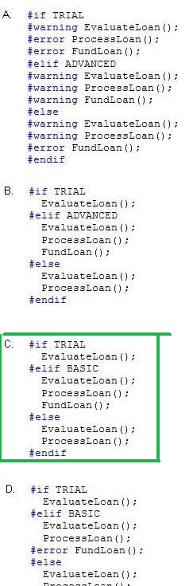

You are creating a console application named App1.  
App1 retrieves data from the Internet by using JavaScript Object Notation (JSON). You are developing the following code segment (line numbers are included for reference only):

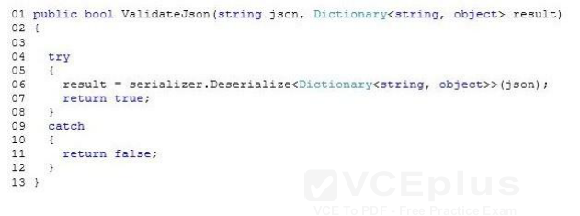  
You need to ensure that the code validates the JSON string. Which code should you insert at line 03?

